When access the blog platform will show a main page like this:

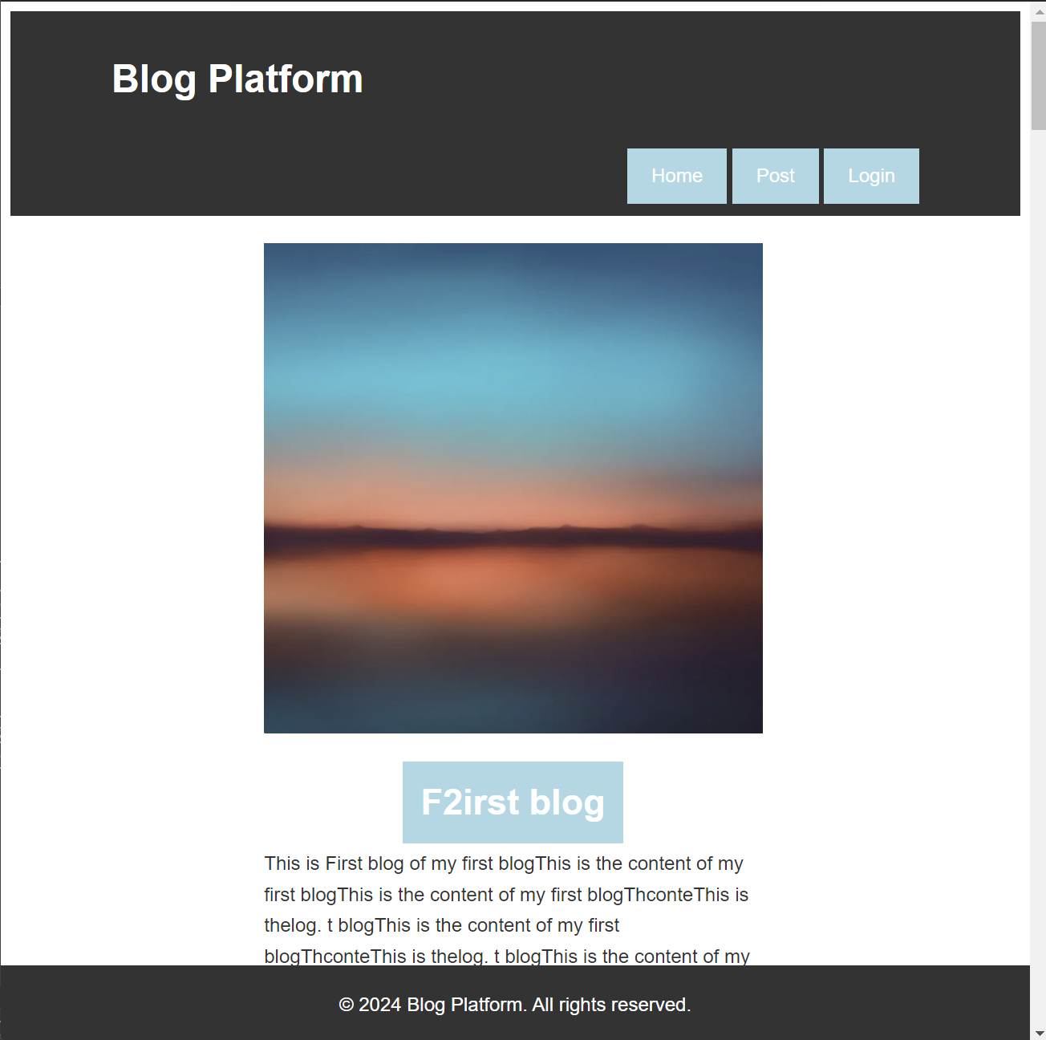

User can scroll down to read the rest blogs.

If user want to post a blog, need to login first, or else will jump to login page.

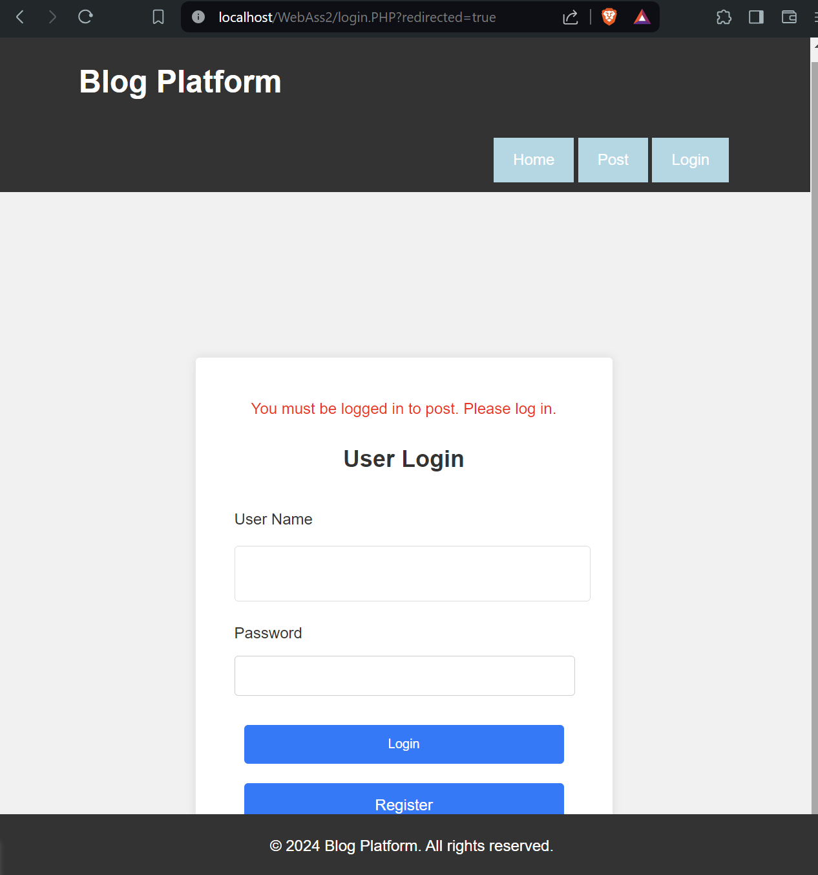

User can create account or jump back to main page to read blogs:

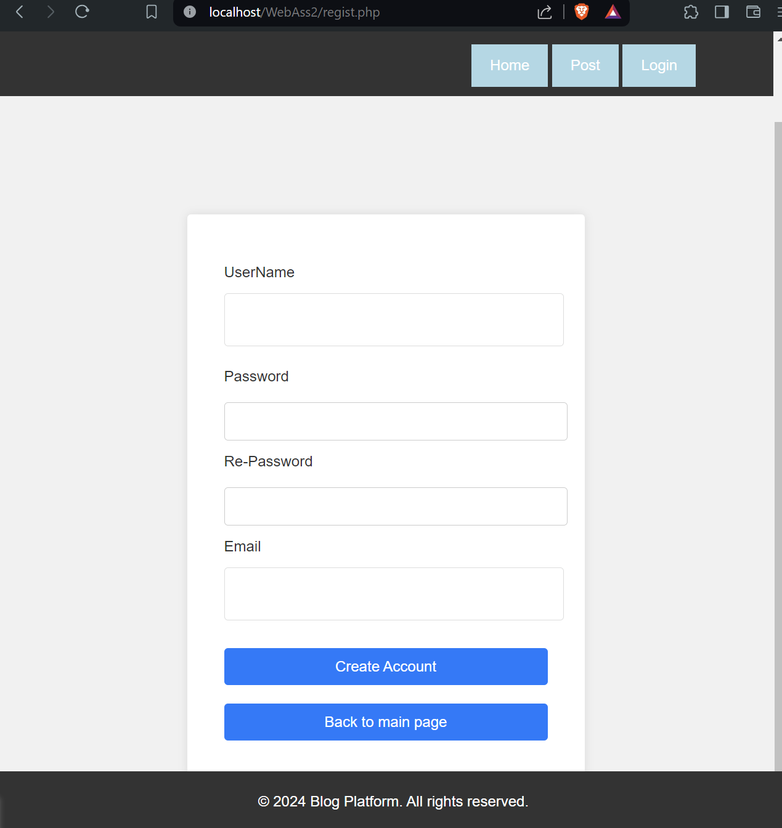

Once user login ,user name will show on the top, and post a new blog

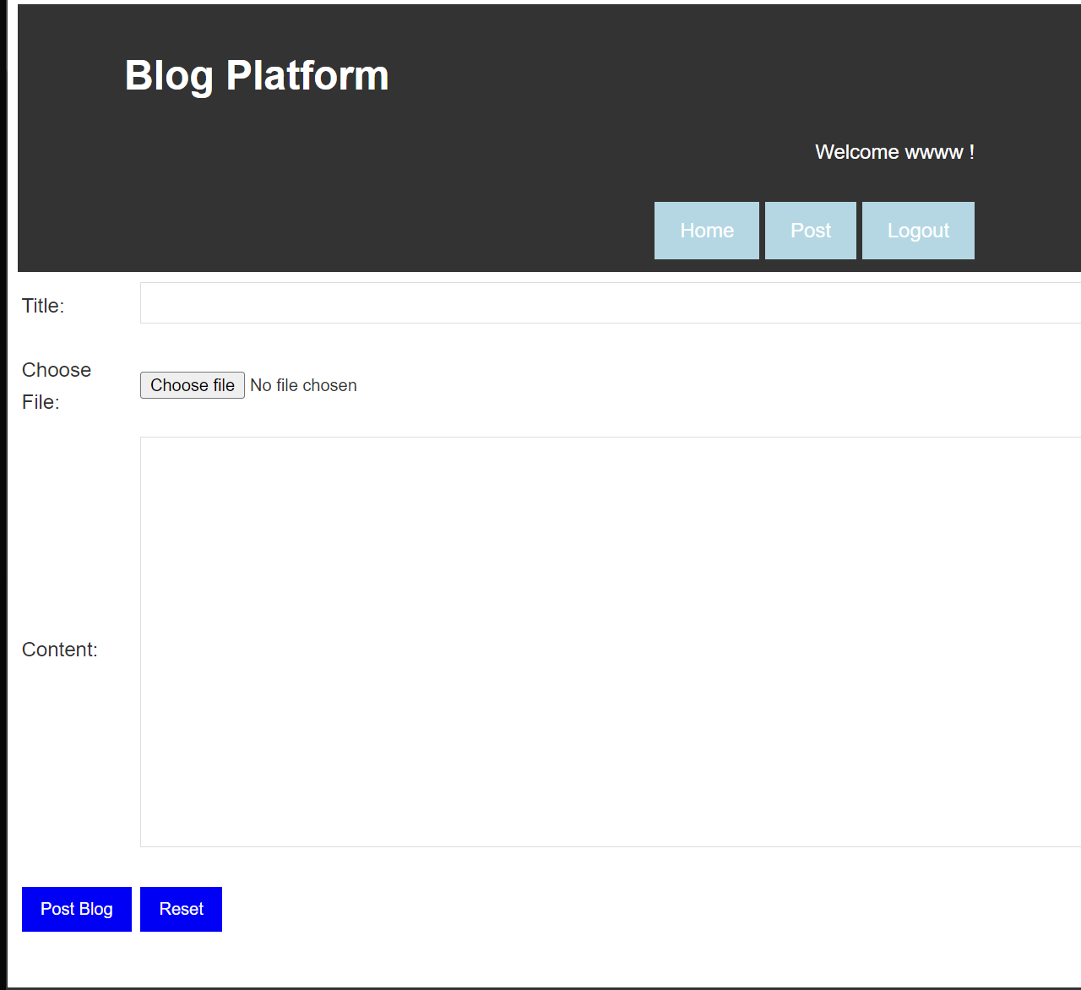

Once user post a blogs, user can go to home page to see it

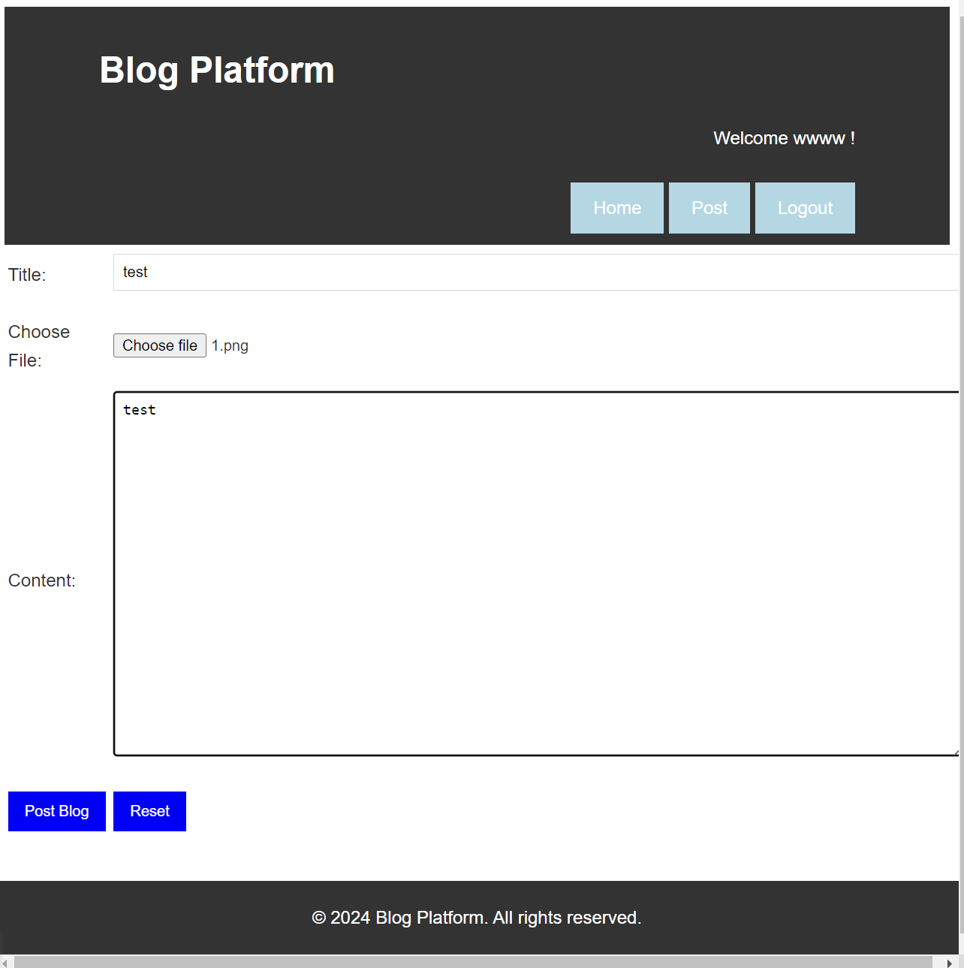

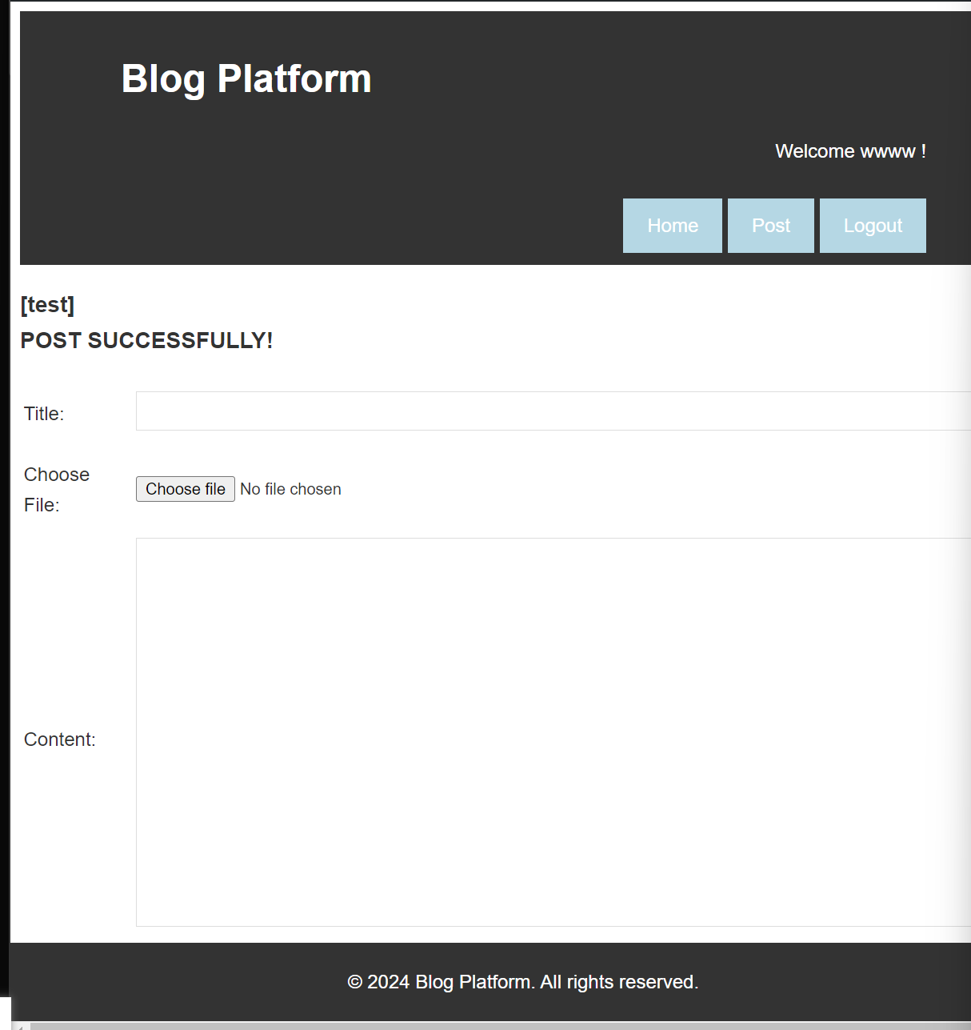

User go to home page now can see the blog post before:

